**Web Development tools and Methods Project**

**Domain:** Retail and Manufacturing

**Scope:**

To design Web application to handle order request for a computer appliance manufacturing company. The system should be able to serve as a common platform for admin, support team, management team, customer and dispatch team to login and use the system to handle the information about the products and manage requests.

* + The customer can create an account to login to the system to raise request for purchasing products.
  + The support team analyses the request and checks with the warehouse and stock to forward the request to management team for contract signing.
  + Management team responds to the request by asking user to fill the contract form and customer after successful payment and contract signing, management team approves the request.
  + The approved request is sent to the dispatch team, who after dispatching the order updates the stock.

The initial DB structure looks like :

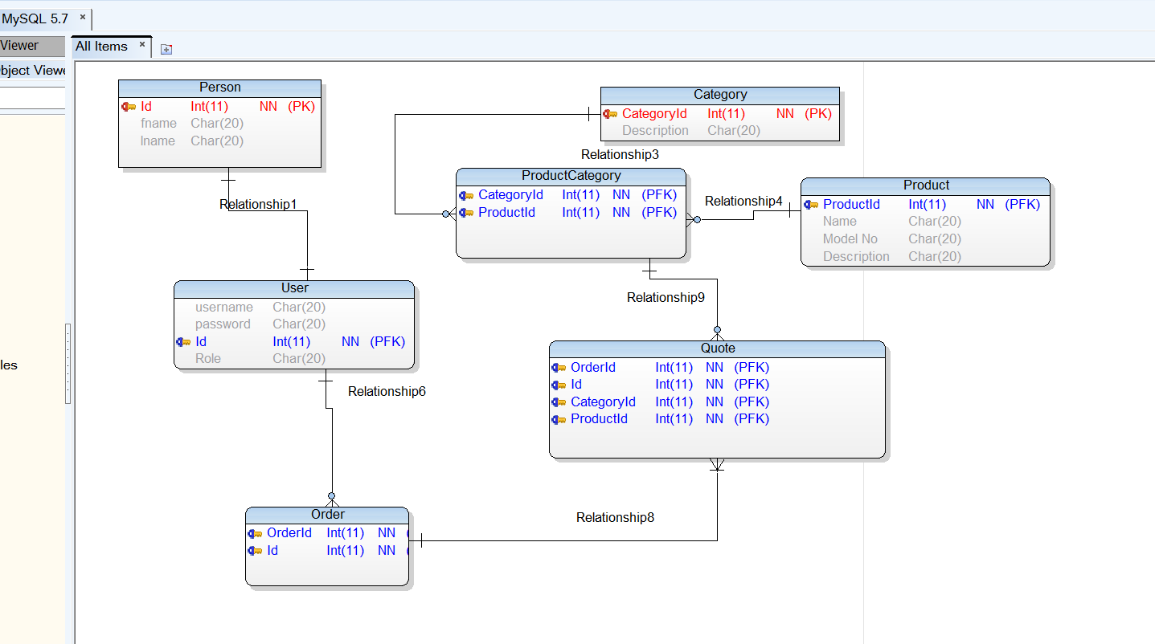

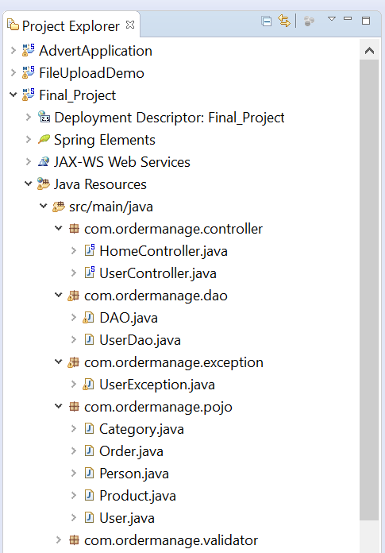

Index.jsp

<%@taglib uri=*"http://java.sun.com/jsp/jstl/core"* prefix=*"c"*%>

<%@taglib uri=*"http://java.sun.com/jsp/jstl/functions"* prefix=*"fn"*%>

<%@page contentType=*"text/html"* pageEncoding=*"UTF-8"*%>

<!DOCTYPE html>

<html>

<head>

<meta http-equiv=*"Content-Type"* content=*"text/html; charset=UTF-8"*>

<title>Order Management</title>

</head>

<body>

<a href=*"user/register.htm"*>Register a new User</a><br/>

<h2>Login</h2>

<form action=*"user/login"* method=*"post"*>

<table>

<tr>

<td>User Name:</td>

<td><input name=*"username"* size=*"30"* required=*"required"* /></td>

</tr>

<tr>

<td>Password:</td>

<td><input type=*"password"* name=*"password"* size=*"30"* required=*"required"*/></td>

</tr>

<tr>

<td colspan=*"2"*><input type=*"submit"* value=*"Login"* /></td>

</tr>

</table>

</form>

</body>

</html>

The views created are :

